Name: Puneet Sharma

Mobile No. : 9664006152

Email : [puneetsharmaps023@gmail.com](mailto:puneetsharmaps023@gmail.com)

Screenshots of the assignment:

For Desktop :

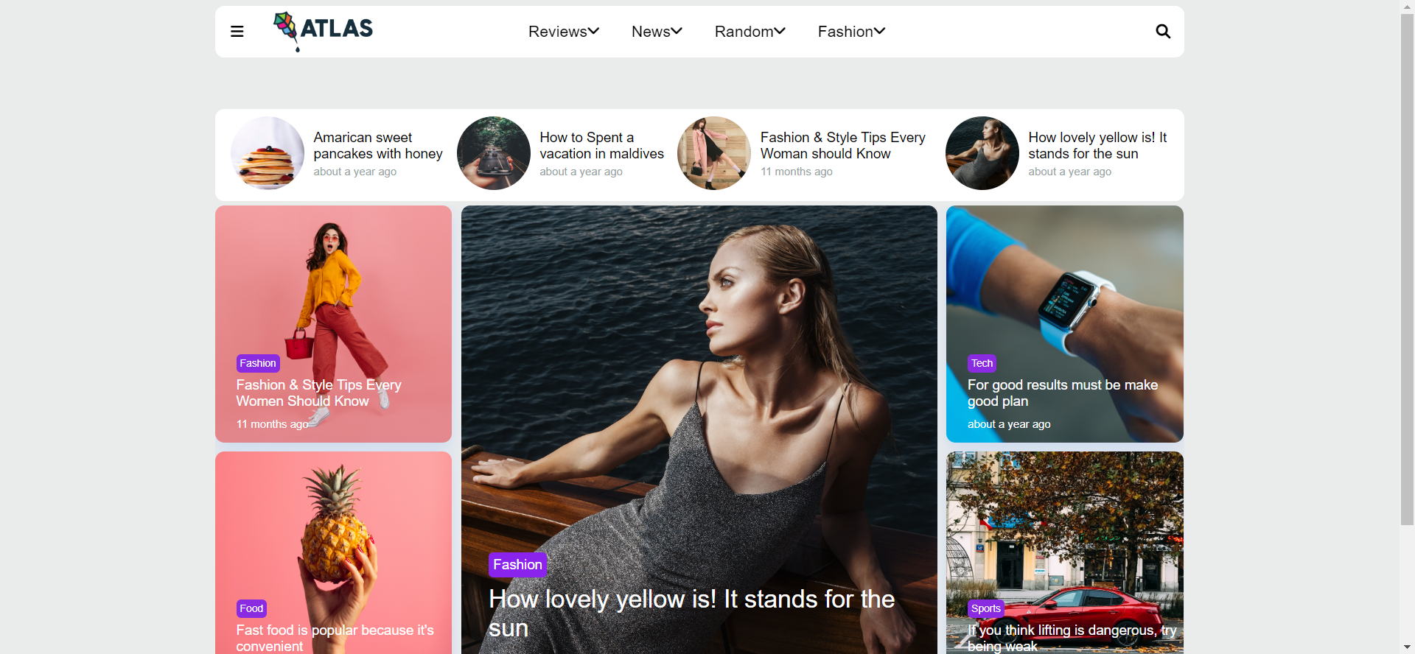

For Mobile Devices :

* Before clicking hamburger menu:



* After clicking the Hamburger Menu

